Bevan Hodder

Stunt Performer
American mobile: (818)2744894
New Zealand mobile: 027-396-7016
New Zealand Home: 09-422-4067
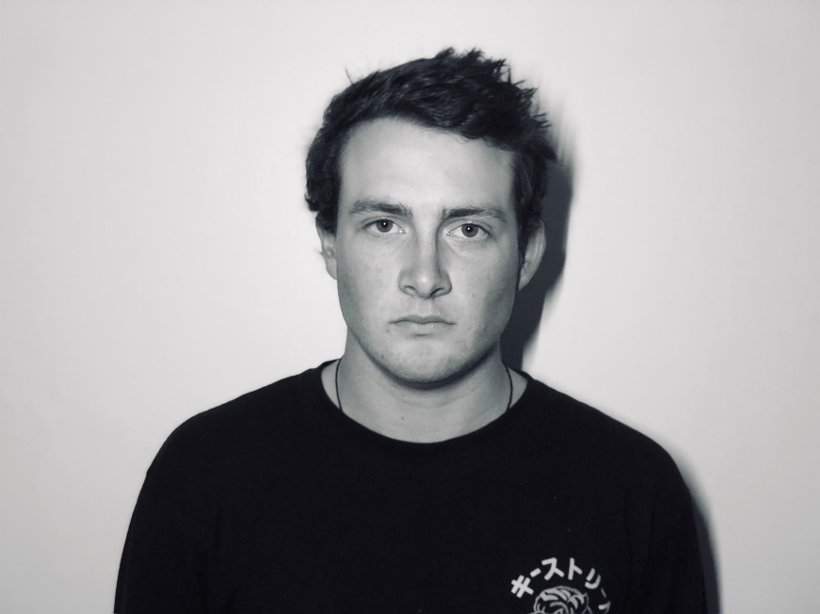

Email: Bevan.hodder@hotmail.com
DOB | 02/05/1997 | Dress or Suit Size | 92 Jacket, 82 Pant
Height | 174 cm | Eye Colour | Hazel
Weight | 69kg | Hair Colour | Brown
Chest/Waist/Hip | 95cm / 75cm / 84cm | Shoe Size | 8 nz / 9 usa / 42eu

Qualifications / Skills / Training
PADI Open Water Dive Certificate, DriveRush Level 4, First Aid Level 1
Air Ram, High Falls, Full Body Fire Burns, Aerial/Wire Work,
Stunt Fighting, Basic Parkour/Gymnastics, Basic Motorcycle Driving
Film Credits & Experience
(Project Name) | (Position in Film) | (Year) | (Feature/TV/Short)
Luminaries | Stunt performer | April 2019 | TV
Runaway millionaires | Stunt performer | December 2018 | Feature Film
Brokenwood Mysteries | Stunt Double/performer | June 2018 | TV
Guns Akimbo | Stunt Performer | May 2018 | Feature Film
Fresh Eggs | Stunt Performer | April 2018 | TV
Be Faithful | Stunt Performer | Aug 2017 | Short film
Ash vs Evil Dead S3 | Stunt Performer | June 2017 | TV
Shannara Chronicles S2 | Stunt Performer | March-May 2017 | TV
Power Rangers | Stunt performer | 2016-2019 | TV
Dear Murderer | Stunt double/performer | Sept, 2016 | TV
Westside S2 | Gang member / stunt performer | Oct, 2015 | TV

