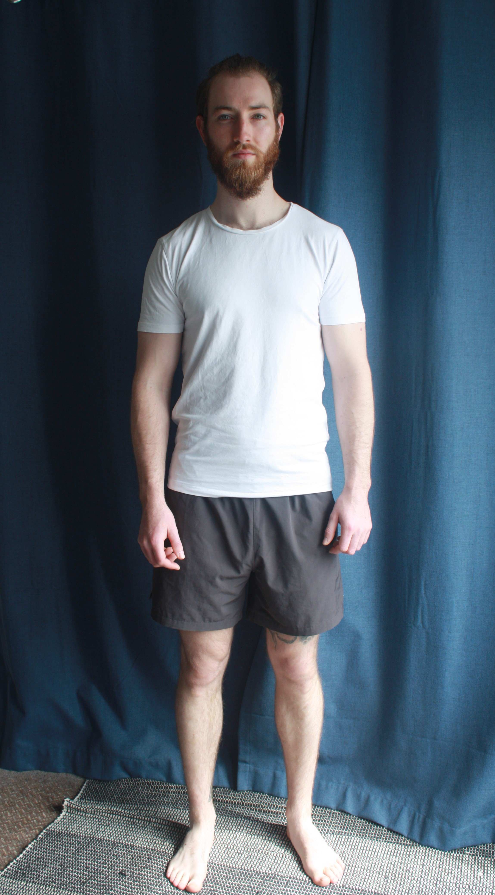 |  | Height: 185cm Chest: 102cm Waist: 82cm Inseam: 81cm Collar: 40.5cm Shoe: 10.5 US Eyes: Blue Hair: Light Brown  Qualifications:  Drive Rush School Stunt Driving Course- Level 4 (2021)  St. John’s First Aid Certificate- Level 2 (2020)  Victoria University of Wellington - B.A: Theatre (Physical Theatre focus) and French (2015-2019)  New Zealand Institute of Health and Fitness – Certificate of Personal Training (2013)  PADI Scuba Diving Open Water Certificate (2013)  Royal Academy of Dance - Classical Ballet: Intermediate (2008). Grade 6 (2006).  NZ Driver’s License: Class 1 (Full), Class 6 (Learner)  Experience:  (SF) 2021- Hotline- Johnny (lead)/ Stunt Performer/ Choreographer- White Label Productions  (Stage) 2021 –That Bloody Woman Musical – William Lovell-Smith- Stagecraft Productions  (FF) 2020 - Avatar Sequels - Featured Extra/ Action Extra-  (Stage) 2017 - The Menagerie Burlesque Show - The Masochism Tango Duet - Burlesque Dancer  (SF) 2017 – Monsters- Jay, Lead Role– NZ Film School (Jason Stutter)  (SF) 2017 - ACC Staff Training video – Phil, Dialogue Role -Inspire Group  (FF) 2017 - Mortal Engines- Stand-in & Engineer -Hungry City Ltd  (TV) 2016 - Catching the Black Widow- Policeman Featured Extra - KHF Media - Thomas Robins-  (FF) 2015 - Ghost in the Shell- Stunt walk-through- LBO Productions-  (Stage) 2015 - Timon of Athens - Core role - Summer Shakespeare  (FF) 2013 - The Hobbit - Elf Extra - 3 Foot 7 Ltd  (Military) 2011–2019- New Zealand Defence Force (ARMY): Infantryman → 2IC → Section Commander  (Muay Thai) Combined Experience of over 5 years (including two fights) at MTI Wellington (Mark Hampton)  Training:  2020 High Falls Workshop (25ft) NZSS  2020 Fight for Camera Workshop- NZSS (SGNZ Stunt Coordinator)  2020 Acting for Film/ TV Workshop - Peter Feeney  2020 Stage Combat and Flying by Wire workshop - Aotearoa Fight Directors  2020 Stunt Workshop – Rodney Cook Stunts (SGNZ Stunt Coordinator)  2019 Advanced Screen Acting Intensive Liz Mullane and Rachel Bullock  2019 Bootcamp Avatar Sequels  2016 Acting for TV Rachel Bullock  CONTACT  +64223208545  aal.dunn@gmail.com  NZ/ UK Citizen  Stunt Guild of New Zealand Probationary

angus Dunn
Actor
Stunt Performer

SKILL | PROFICIENCY
Abseiling | 1
Archery | 1
Boxing | 2
Choreography | 1
Dance | 2
Stunt Driving | 1
Firearms | 3
High Falls  Harness Wirework  Jet-skiing  Martial Arts  Motorbike  Muay Thai  Parkour  Scuba Diving  Swordwork  Snow Skiing  Tactical/ Military  Weapons Systems | 1  1  1  3  2  3  1  2  2  2  3  3

1= 1-3 years exp./ 2= 4-6 years exp. / 3= 7+ years exp.

