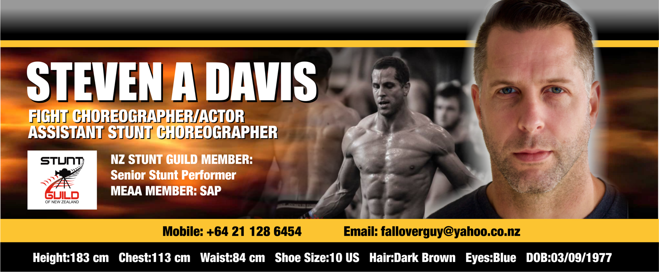
FIGHT CHOREOGRAPHER

CAT. PRODUCTION ROLE/CREDITS YEAR
TV The Shannara Chronicles: S2 Fight Choreographer/Ass. Stunt Coordinator 2017
FF Mohenjo Daro Fight Choreographer 2015
FF The Hobbit: The Battle of Five Armies Stunt Dbl/Additional Sword Master 2013
FF The Hobbit: The Desolation of Smaug Stunt Dbl/Add. Sword Master 2011-2013
FF The Warriors Way Stunt Dbl/Performer/Fight Assist 2007-2008

STUNT PERFORMER EXPERIENCE

CAT. PRODUCTION ROLE/CREDITS YEAR
TV Warrior Stunt Performer 2018
FF Thugs of Hindostan Lead Stunt Dbl 2018
SF Do No Harm Stunt Performer 2016
FF Ghost in the Shell Lead Stunt Dbl 2016
FF Gods of Egypt Lead Stunt Dbl 2014
FF The Hobbit: An Unexpected Journey Stunt Performer 2011-2013
FF Vertical Limit Stunt Performer 1999-2000
TV Step Dave Stunt Actor 2013
TV Spartacus: War of the Damned Stunt Dbl/Performer 2012
TV Power Rangers: Samurai Stunt Performer 2010-2011
TV Spartacus: Gods of the Arena Stunt Dbl/Actor 2010
TV Spartacus: Blood and Sand Stunt Dbl/Performer 2009
TV Power Rangers: RPM Stunt Dbl/Performer 2008-2009
TV Power Rangers: Jungle Fury Stunt Performer 2008
TV Cleopatra 2525 Stunt Performer 1999
TV Xena: Warrior Princess Stunt Performer 1998-1999
TV Hercules: The Legendary Journeys Stunt Performer 1998
TVC Maritime NZ ‘Jacket’ Stunt Dbl 2013
TVC Rabo Bank ‘Dojo’ Stunt Performer 2007
TVC ACC ‘Stair fall’ Stunt Actor 2003
TVC Mars Bars ‘Kick’ Stunt Actor 2002

ACTING EXPERIENCE

CAT. PRODUCTION ROLE/CREDITS YEAR
FF Meg Speed Boat 1st Crewman 2016
TV Power Rangers: Samurai Jayden’s Father 2011
TV Spartacus: Gods of the Arena Indus 2011
TV This Is Not My Life Gordon Leach (core cast) 2010
TV Go Girls Campbell 2010
SHORT FILMS EXPERIENCE

CAT. PRODUCTION ROLE/CREDITS YEAR
SF Take Writer/Director 2005
SF Bigger Fish Writer/Director 2004
SF The Fanimatrix: Run Program Writer/Producer 2003
QUALIFICATIONS/TRAINING/ADDITIONAL DETAILS

- 22 Years Martial Arts - Wushu, Kung Fu, Tae Kwon Do, Capoiera, Judo
- PADI Divemaster - (includes Rescue Diver)
- Vertical Horizonz Group (Industry Courses) EWP, Fall Arrest Systems, Fire Safety, Health and Safety, Workplace First Aid, Advanced Driving
- Rally Drive NZ Ltd - Two Day Rally School
- Workplace Medic First - Aid Medic One Source
- Bachelor of Performing & Screen Arts
- Graduate Meisner Acting Technique
REFERRALS

Tim Wong (NZSG Stunt Coordinator) +64 21 874 270 gwanga@xtra.co.nz
Glenn Boswell (SAG/MEAA Stunt Coordinator) +61 412 131 111 glennboswell@mac.com
Augie Davis (NZSG Stunt Coordinator) +64 21 799 889 ginger.reef@xtra.co.nz

